**Bi-variate Analysis**

Bi-variate Analysis finds out the relationship between two variables. Here, we look for association and disassociation between variables at a pre-defined significance level. We can perform bi-variate analysis for any combination of categorical and continuous variables. The combination can be: Categorical & Categorical, Categorical & Continuous and Continuous & Continuous. Different methods are used to tackle these combinations during analysis process.

Let’s understand the possible combinations in detail:

**Continuous & Continuous:**While doing bi-variate analysis between two continuous variables, we should look at scatter plot. It is a nifty way to find out the relationship between two variables. The pattern of scatter plot indicates the relationship between variables. The relationship can be linear or non-linear.

[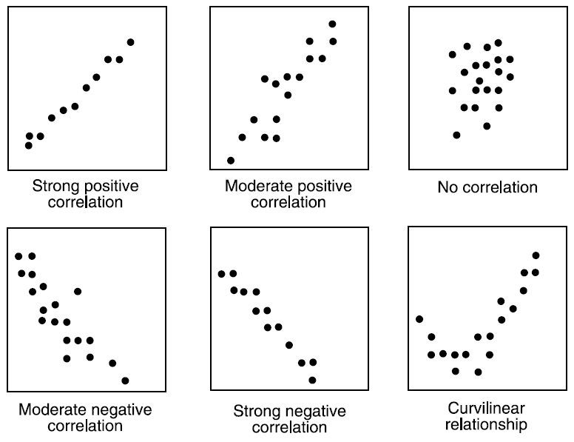](https://www.analyticsvidhya.com/wp-content/uploads/2015/02/Data_exploration_4.png)Scatter plot shows the relationship between two variable but does not indicates the strength of relationship amongst them. To find the strength of the relationship, we use Correlation. Correlation varies between -1 and +1.

* -1: perfect negative linear correlation
* +1:perfect positive linear correlation and
* 0: No correlation

Correlation can be derived using following formula:

**Correlation = Covariance(X,Y) / SQRT( Var(X)* Var(Y))**

Various tools have function or functionality to identify correlation between variables. In Excel, function CORREL() is used to return the correlation between two variables and SAS uses procedure PROC CORR to identify the correlation. These function returns Pearson Correlation value to identify the relationship between two variables:

[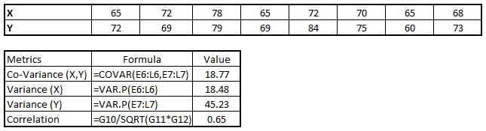](https://www.analyticsvidhya.com/wp-content/uploads/2015/02/Data_exploration_51.png)

In above example, we have good positive relationship(0.65) between two variables X and Y.

**Categorical & Categorical:**To find the relationship between two categorical variables, we can use following methods:

* **Two-way table:** We can start analyzing the relationship by creating a two-way table of count and count%. The rows represents the category of one variable and the columns represent the categories of the other variable. We show count or count% of observations available in each combination of row and column categories.
* **Stacked Column Chart:**This method is more of a visual form of Two-way table.

[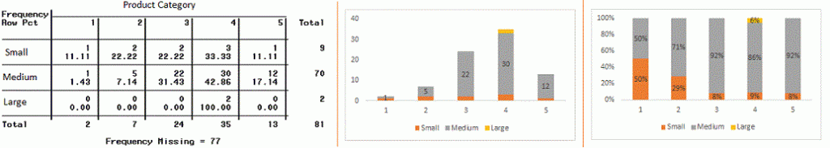](https://www.analyticsvidhya.com/wp-content/uploads/2015/02/Data_exploration_6.gif)

* **Chi-Square Test:** This test is used to derive the statistical significance of relationship between the variables. Also, it tests whether the evidence in the sample is strong enough to generalize that the relationship for a larger population as well. Chi-square is based on the difference between the expected and observed frequencies in one or more categories in the two-way table. It returns probability for the computed chi-square distribution with the degree of freedom.

Probability of 0: It indicates that both categorical variable are dependent

Probability of 1: It shows that both variables are independent.

Probability less than 0.05: It indicates that the relationship between the variables is significant at 95% confidence. The chi-square test statistic for a test of independence of two categorical variables is found by:

[Data Exploration, Chi Square, Business Analytics](https://www.analyticsvidhya.com/wp-content/uploads/2015/02/Data_exploration_7.png)where *O* represents the observed frequency. *E* is the expected frequency under the null hypothesis and computed by:  
[Data Exploration, Chi Square, Business Analytics](https://www.analyticsvidhya.com/wp-content/uploads/2015/02/Data_exploration_8.png)  
From previous two-way table, the expected count for product category 1 to be of small size is  0.22. It is derived by taking the row total for Size (9) times the column total for Product category (2) then dividing by the sample size (81). This is procedure is conducted for each cell. Statistical Measures used to analyze the power of relationship are:

* Cramer’s V for Nominal Categorical Variable
* Mantel-Haenszed Chi-Square for ordinal categorical variable.

Different data science language and tools have specific methods to perform chi-square test. In SAS, we can use **Chisq** as an option with **Proc freq** to perform this test.

**Categorical & Continuous:**While exploring relation between categorical and continuous variables, we can draw box plots for each level of categorical variables. If levels are small in number, it will not show the statistical significance. To look at the statistical significance we can perform Z-test, T-test or ANOVA.

* **Z-Test/ T-Test:-** Either test assess whether mean of two groups are statistically different from each other or not.[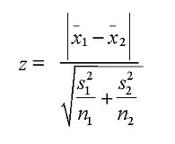](https://www.analyticsvidhya.com/wp-content/uploads/2015/02/ztestformula1.jpg)If the probability of Z is small then the difference of two averages is more significant. The T-test is very similar to Z-test but it is used when number of observation for both categories is less than 30.  
  [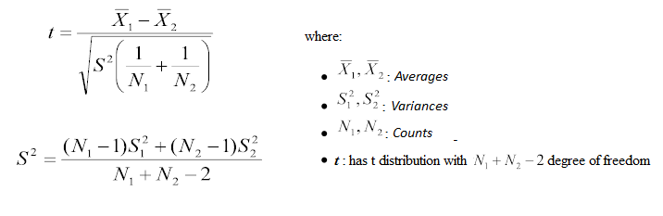](https://www.analyticsvidhya.com/wp-content/uploads/2015/02/ttest.png)
* **ANOVA:-**It assesses whether the average of more than two groups is statistically different.

**Example:** Suppose, we want to test the effect of five different exercises. For this, we recruit 20 men and assign one type of exercise to 4 men (5 groups). Their weights are recorded after a few weeks. We need to find out whether the effect of these exercises on them is significantly different or not. This can be done by comparing the weights of the 5 groups of 4 men each.

Till here, we have understood the first three stages of Data Exploration, Variable Identification, Uni-Variate and Bi-Variate analysis. We also looked at various statistical and visual methods to identify the relationship between variables.

Now, we will look at the methods of Missing values Treatment. More importantly, we will also look at why missing values occur in our data and why treating them is necessary.